**INFOLABZ IT SERVICES PVT. LTD.**

**Course :** React

**Session No :** 22

**Topics to be covered :** Adding Bootstrap to react : Bootstrap buttons, Bootstrap tables, Bootstrap Alerts, Alertify Package

1. Create new react project

Name it: reactbootstrap

1. **Official React documentation website**

Link : <https://react-bootstrap.netlify.app/docs/getting-started/introduction>

1. Open project in visual studio code
2. Go to terminal and install react bootstrap

npm install react-bootstrap bootstrap

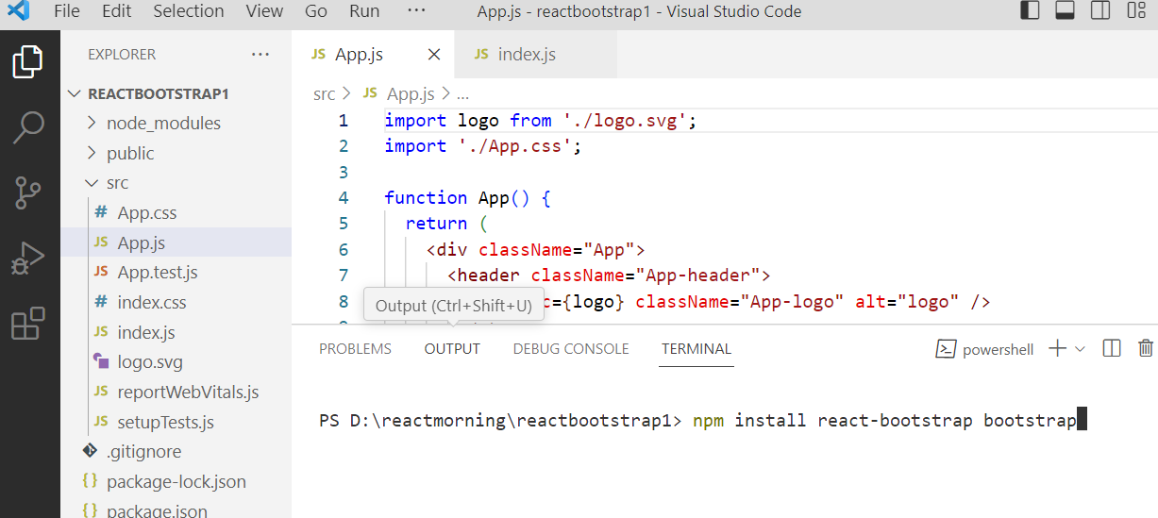

1. Import CSS file in App.js ( where we want to use bootstrap )

import 'bootstrap/dist/css/bootstrap.min.css';

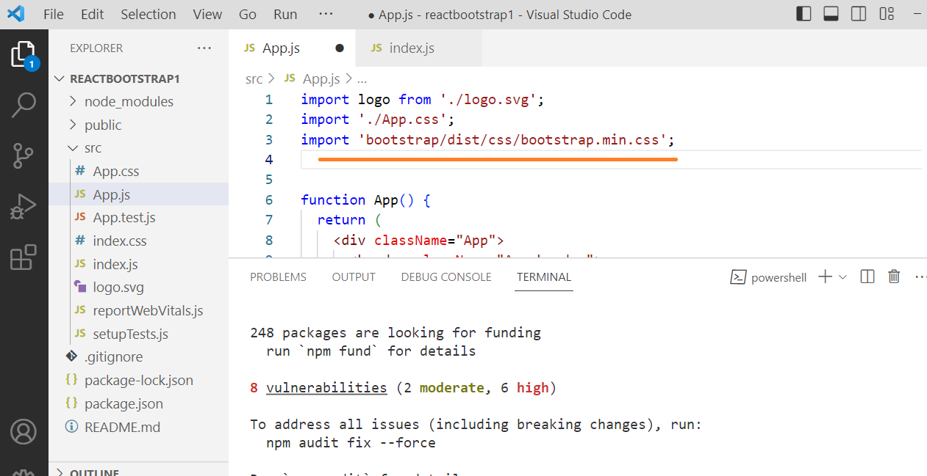

APP.JS

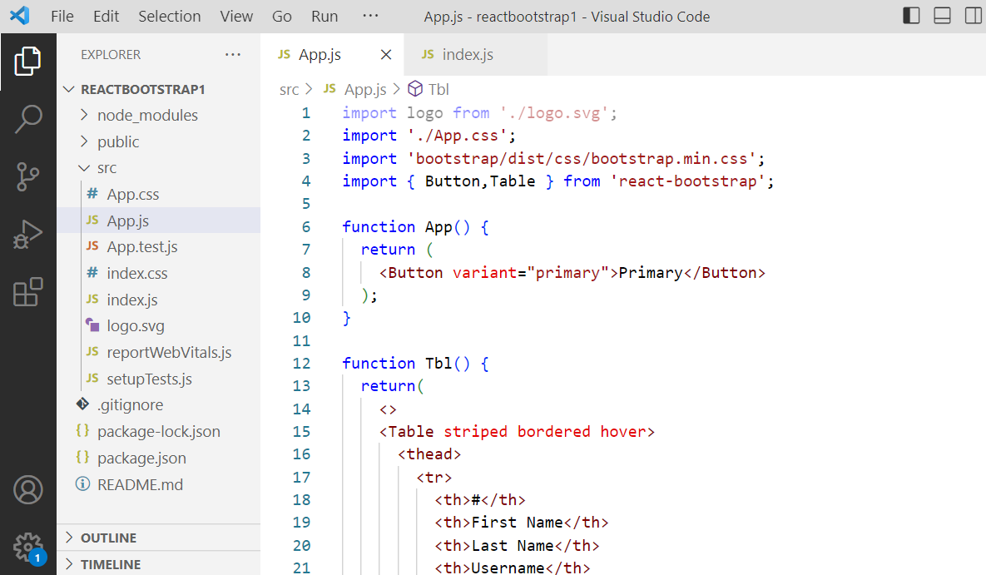

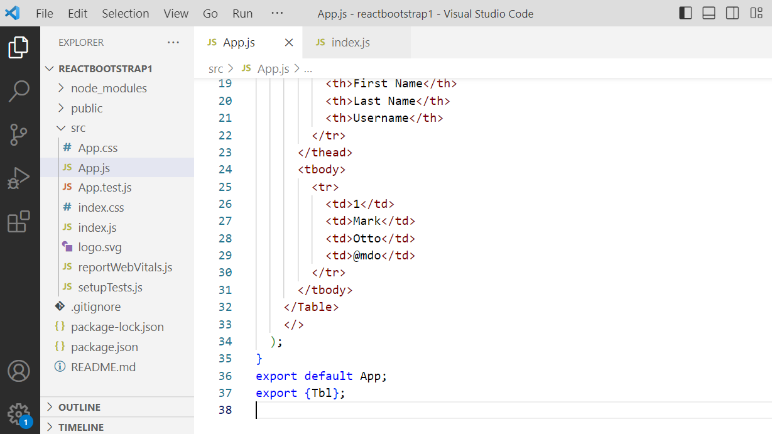

Index.js

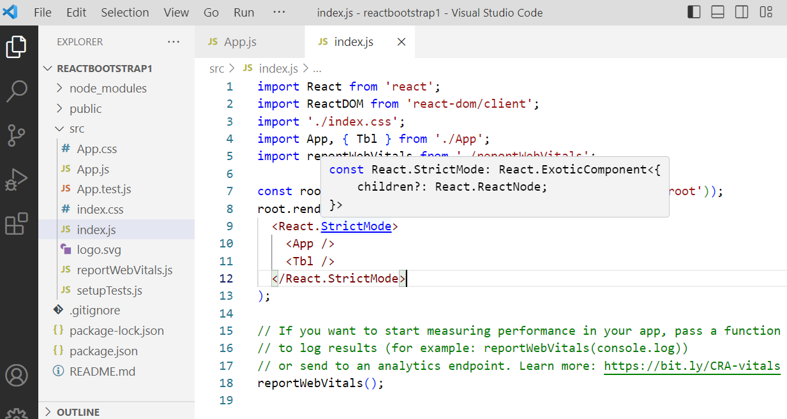

Output :

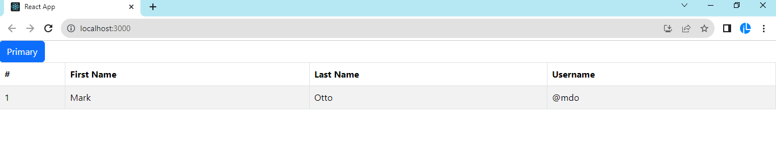

JAVA SCRIPT :

JS POP-UP BOXES

1. **ALERT**

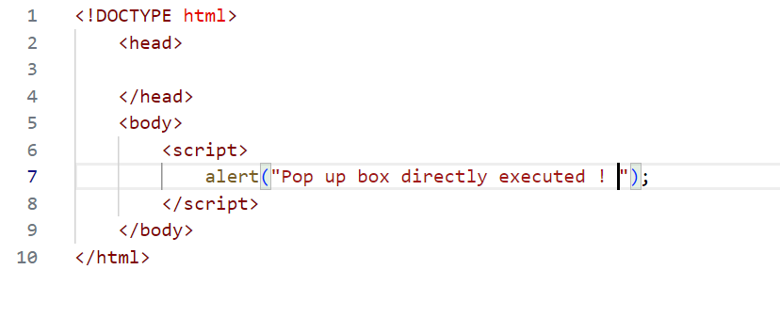

**On click :**

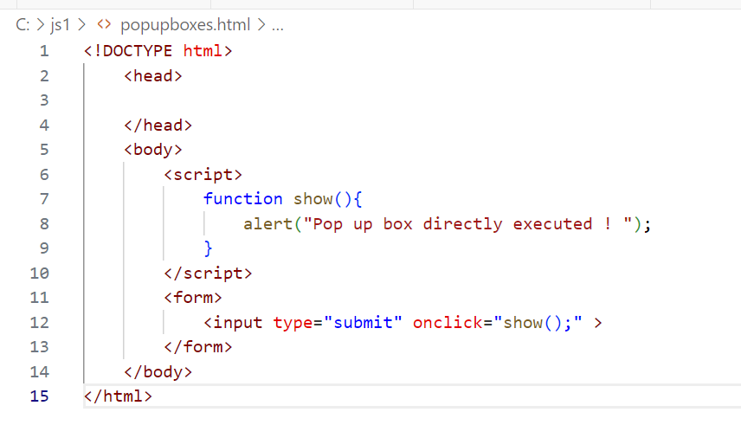

**PROMPT :**

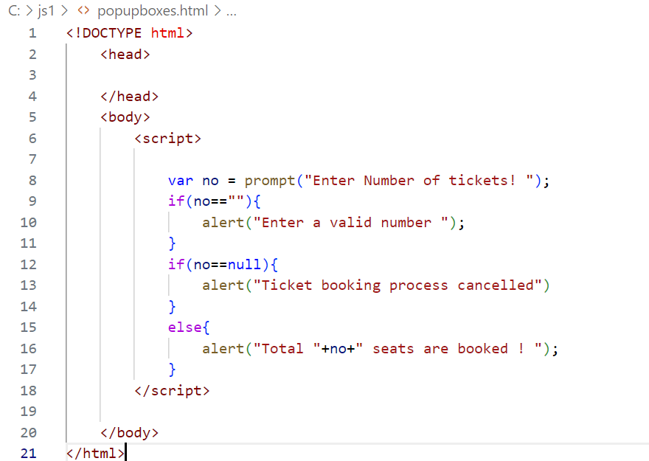

Confirm :

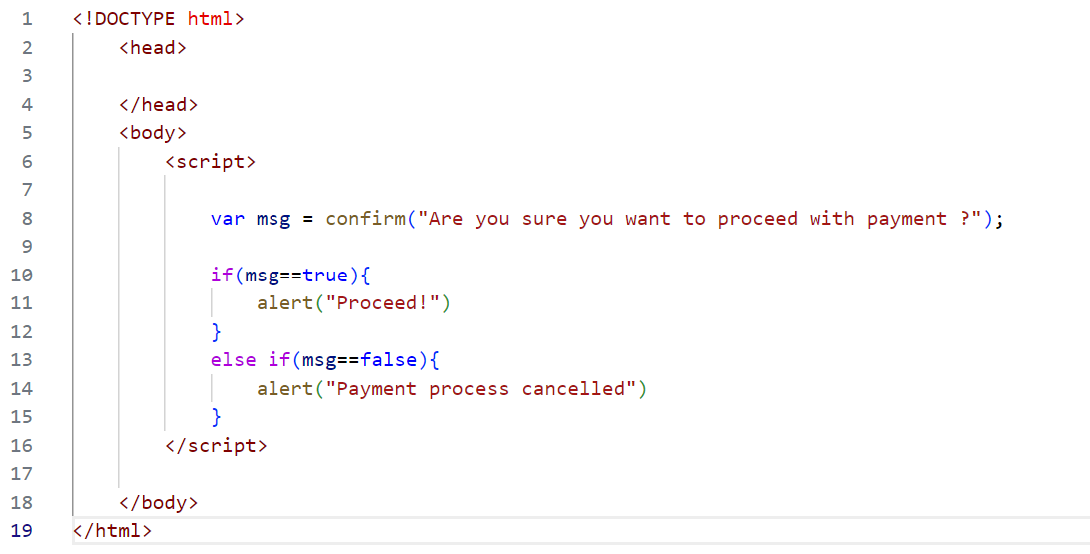

PRACTICE WORK : [CLICK HERE](https://docs.google.com/document/d/1HL0NuEbl84Sj8_Mtw7fqQnLpUw2OWgKjwkOwlbMzR2s/edit?usp=sharing)